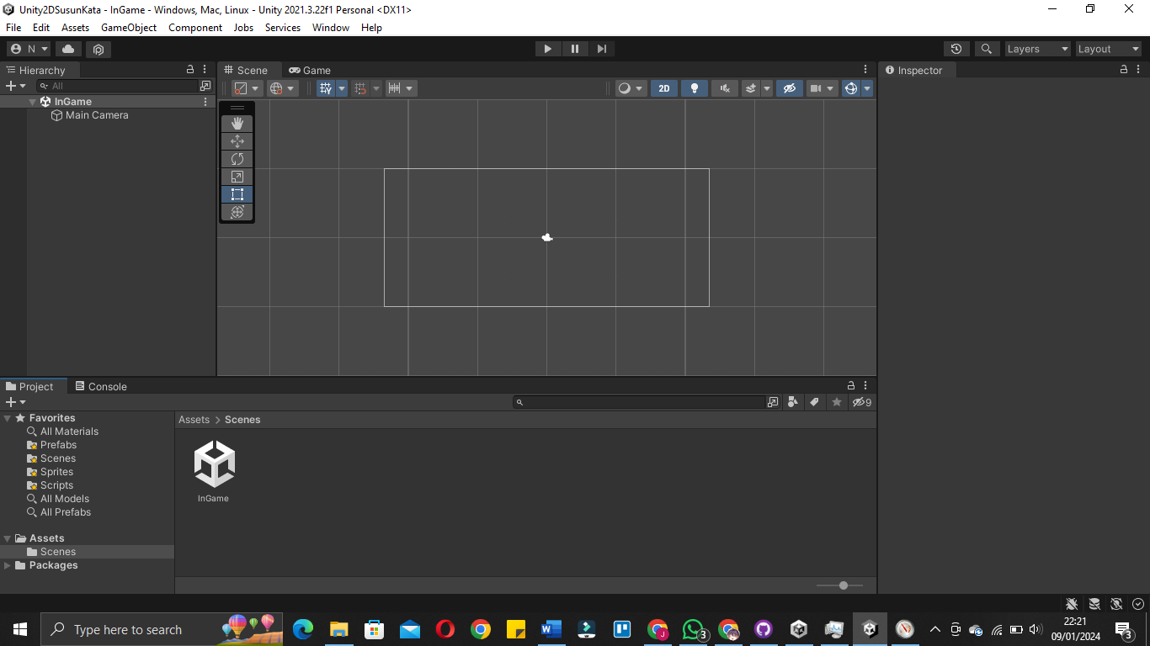

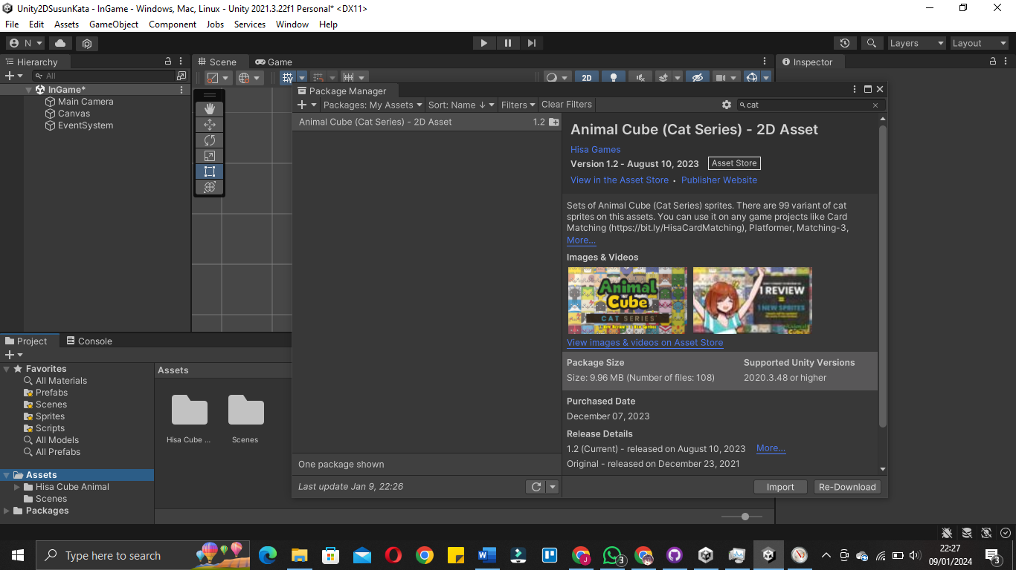

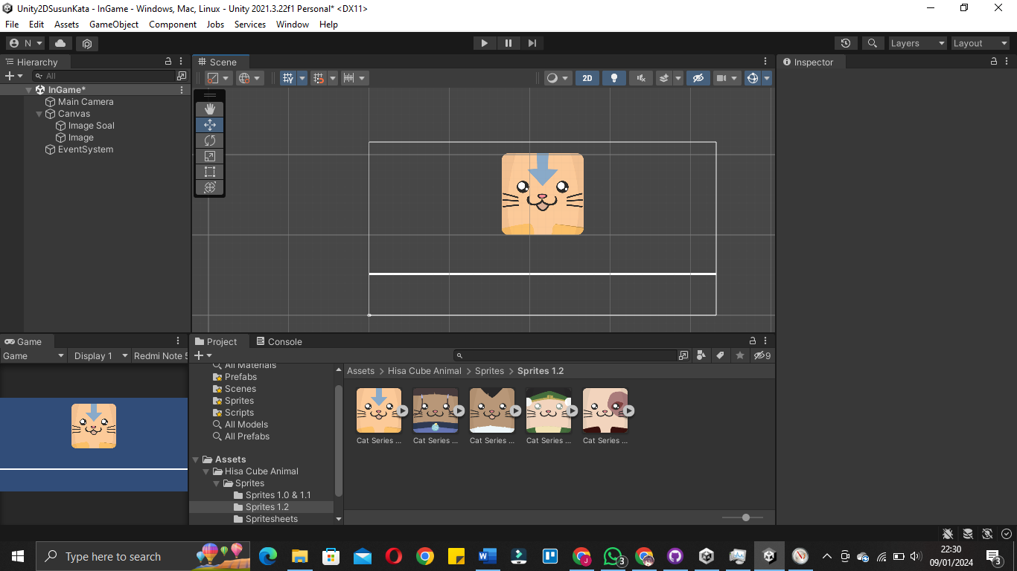

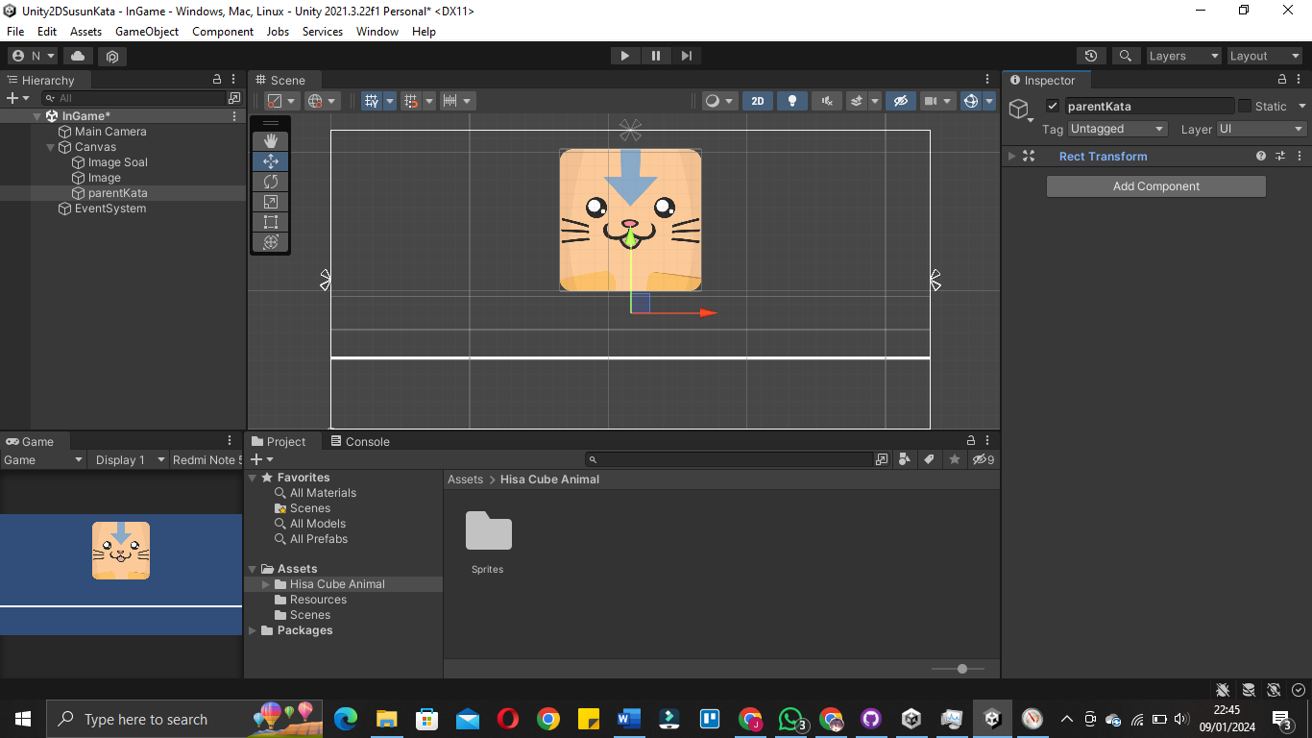

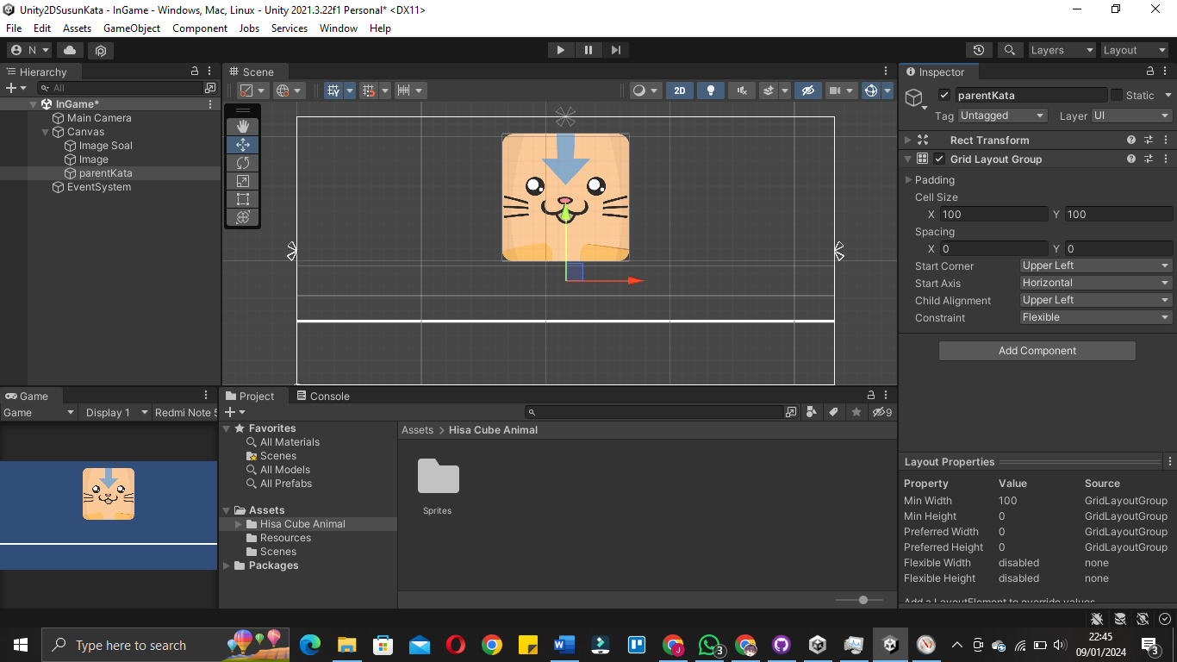

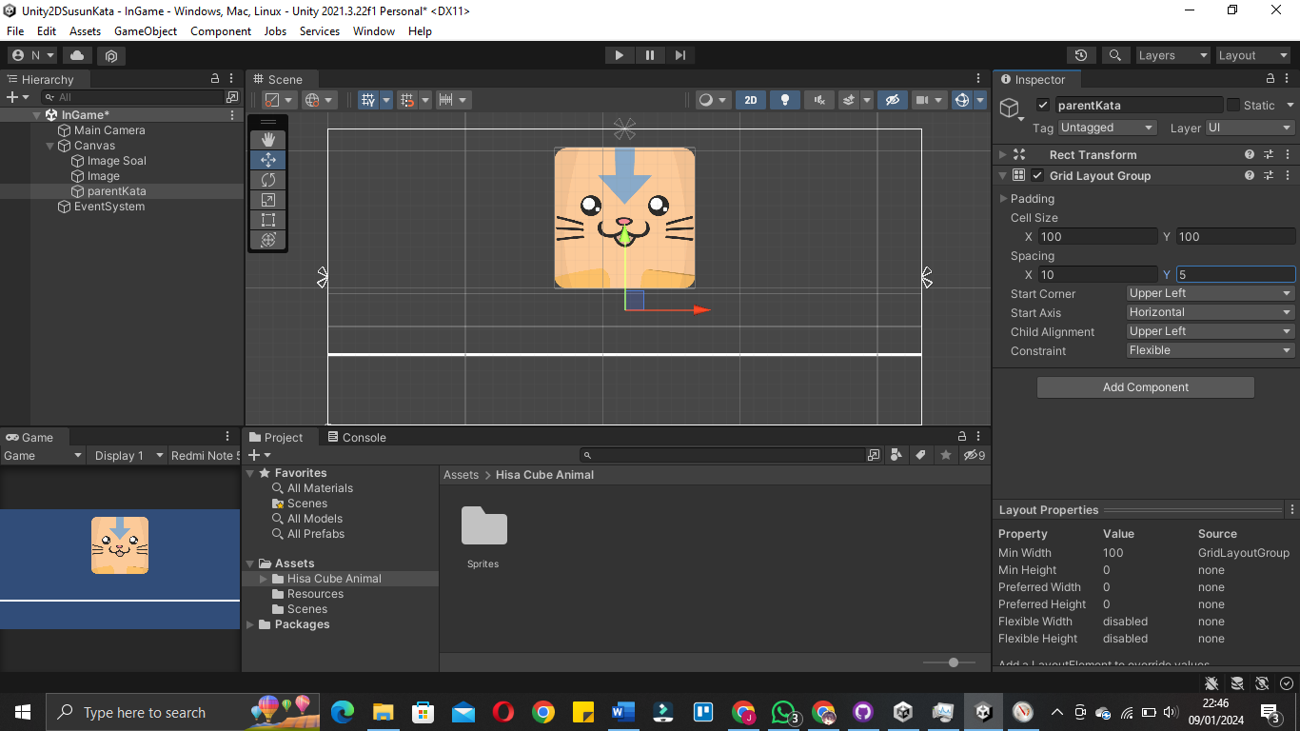

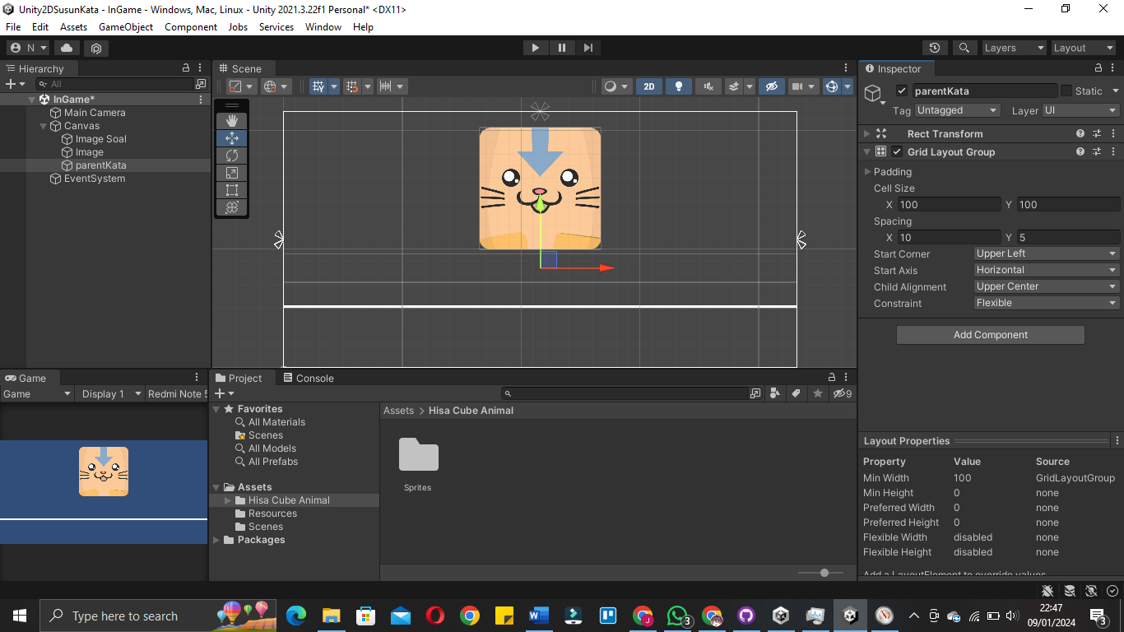

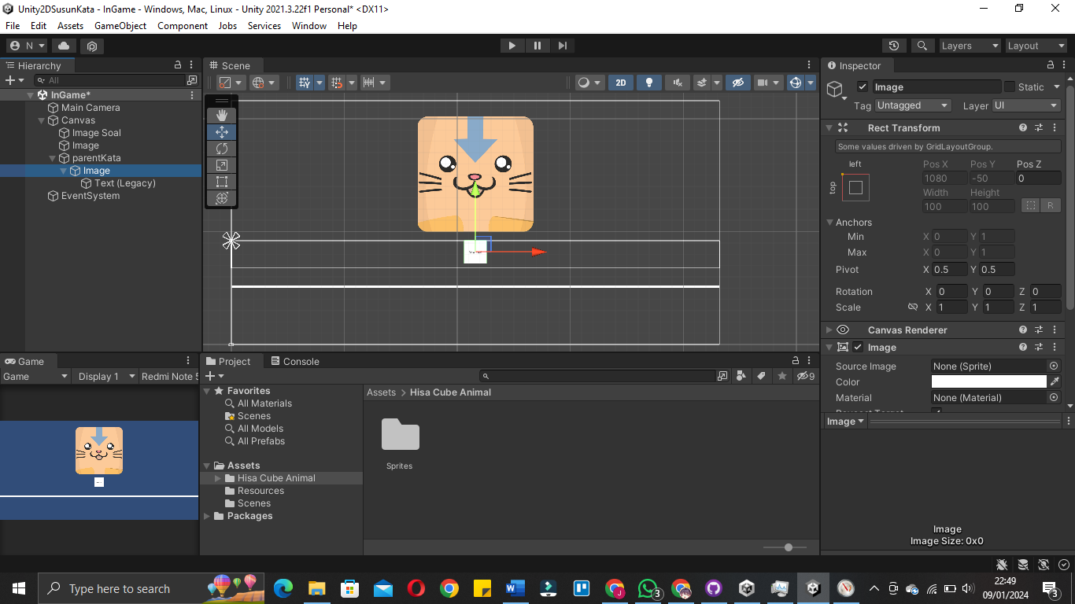

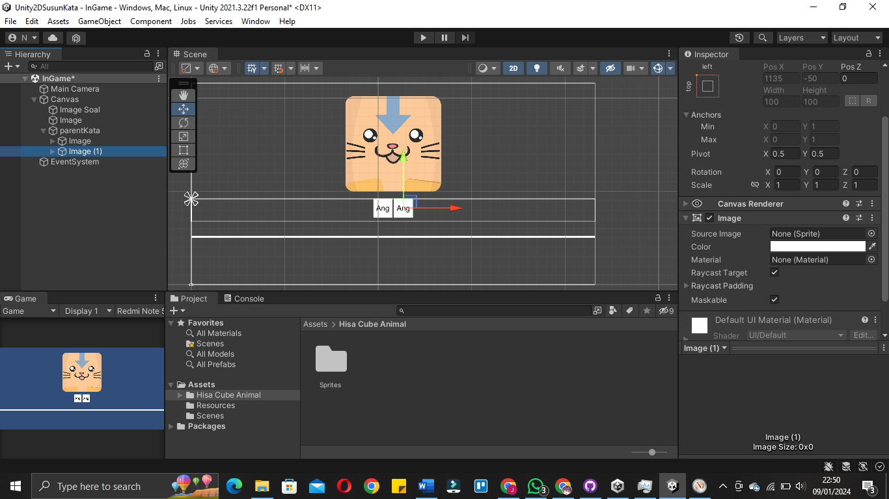

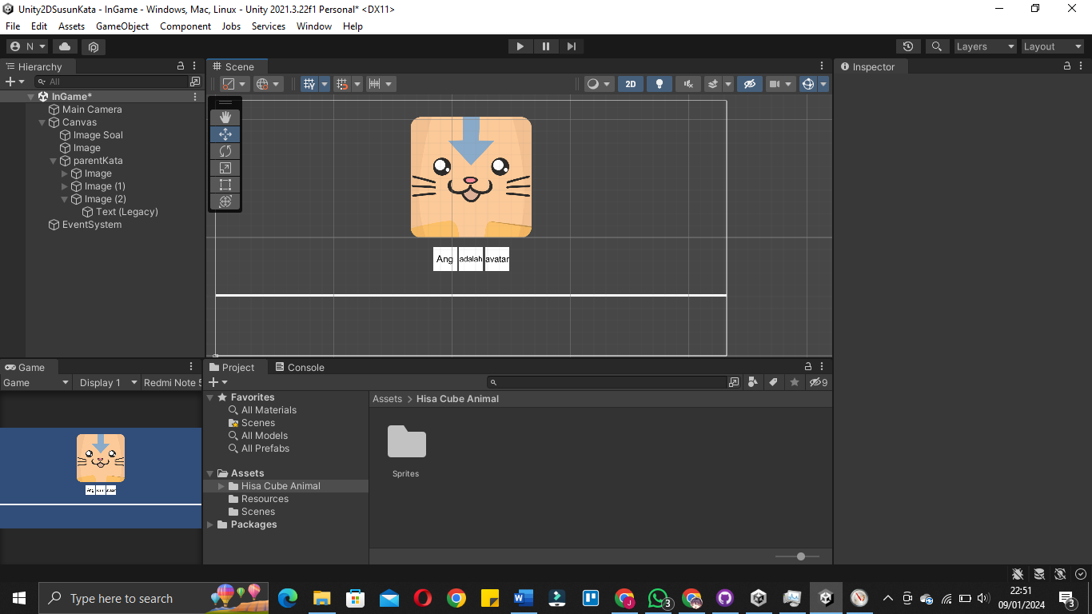

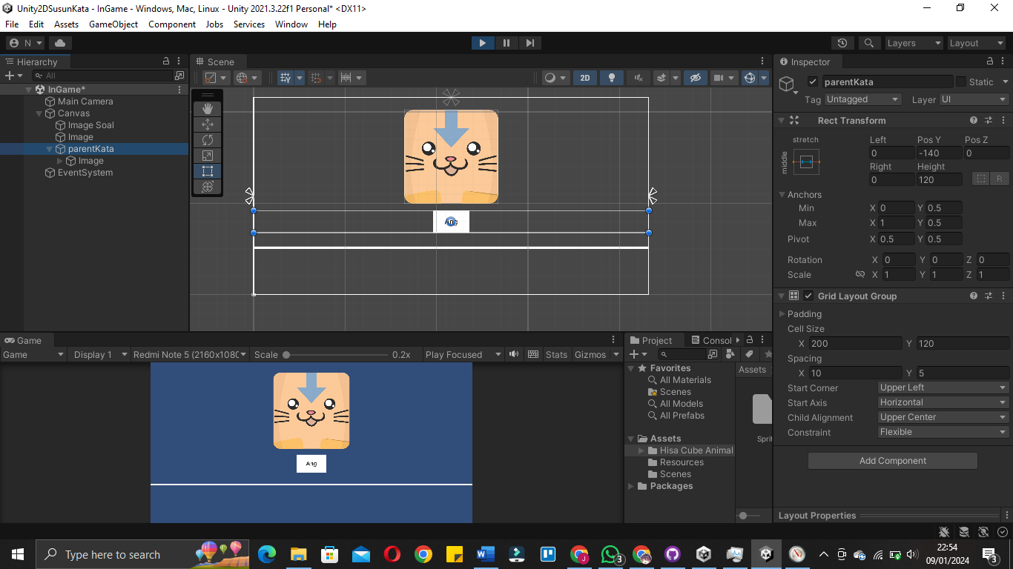

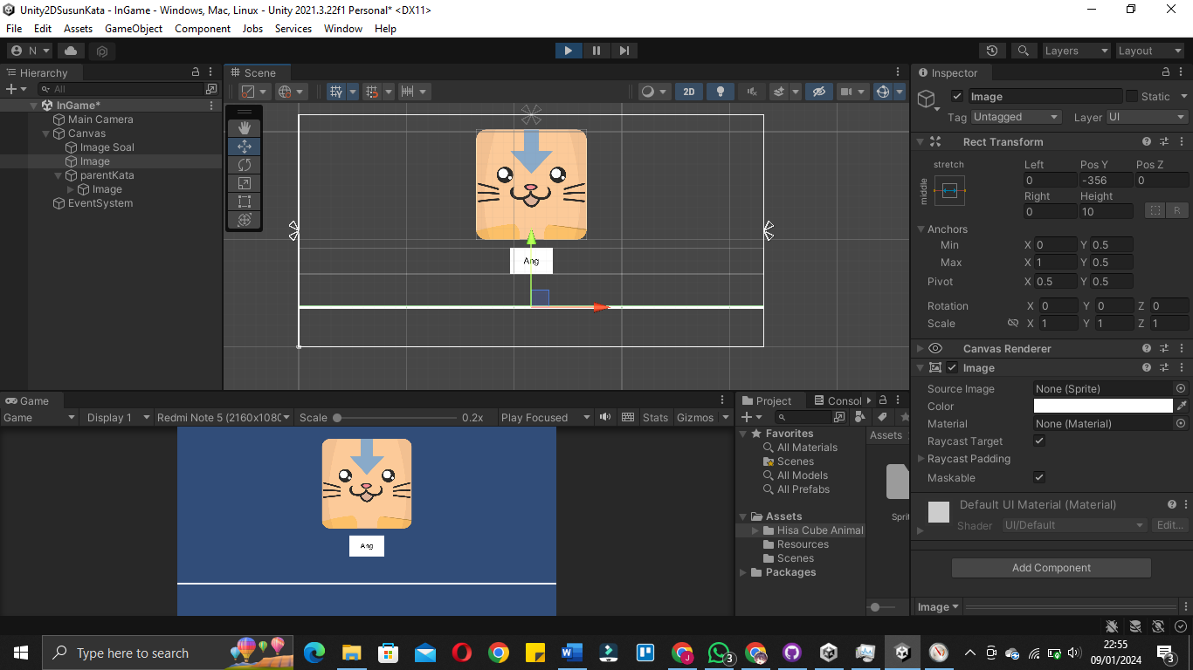

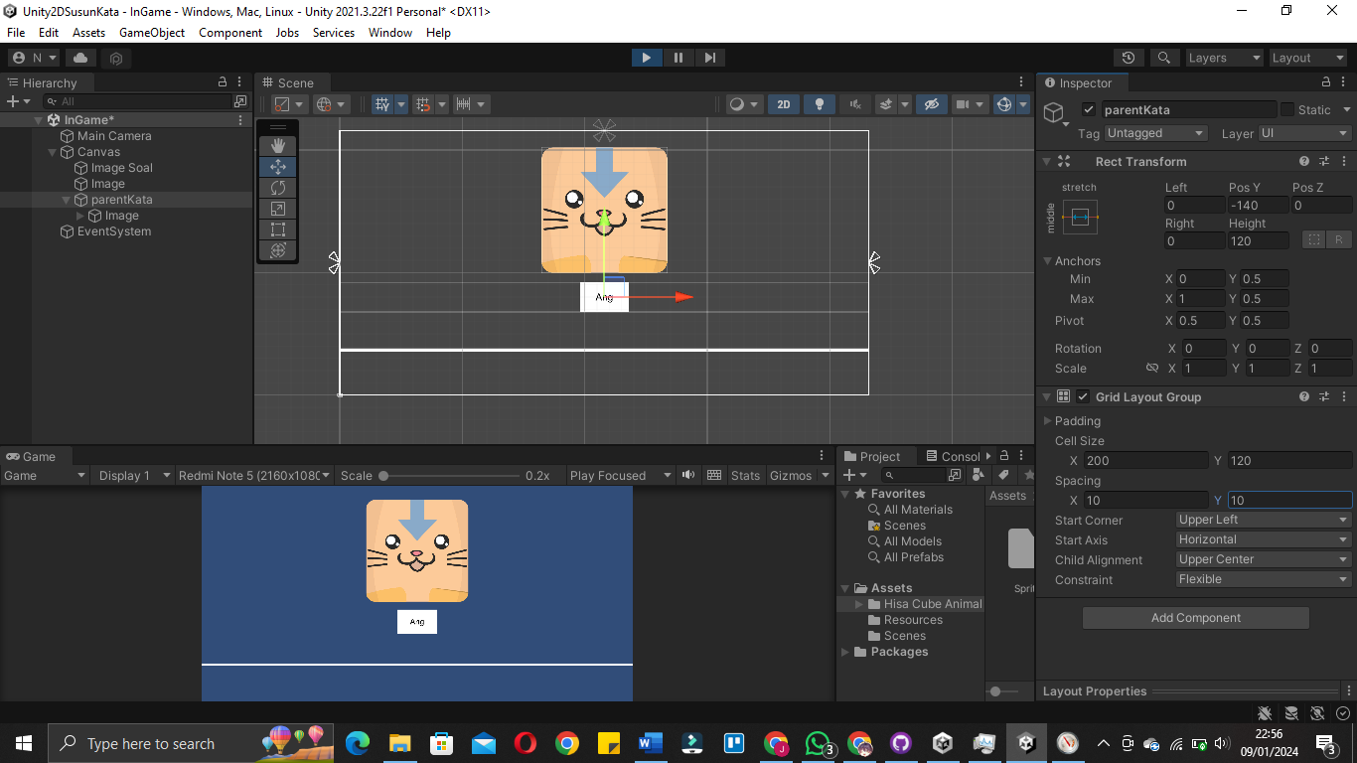

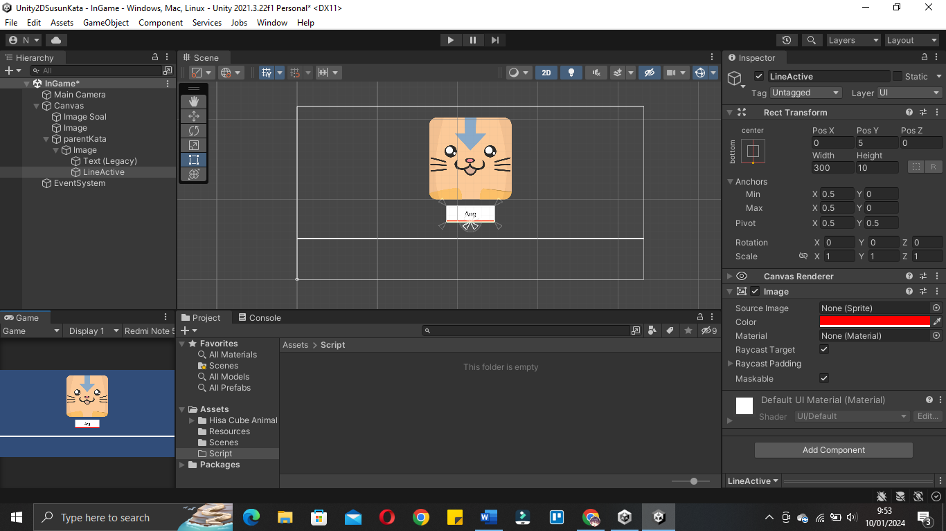

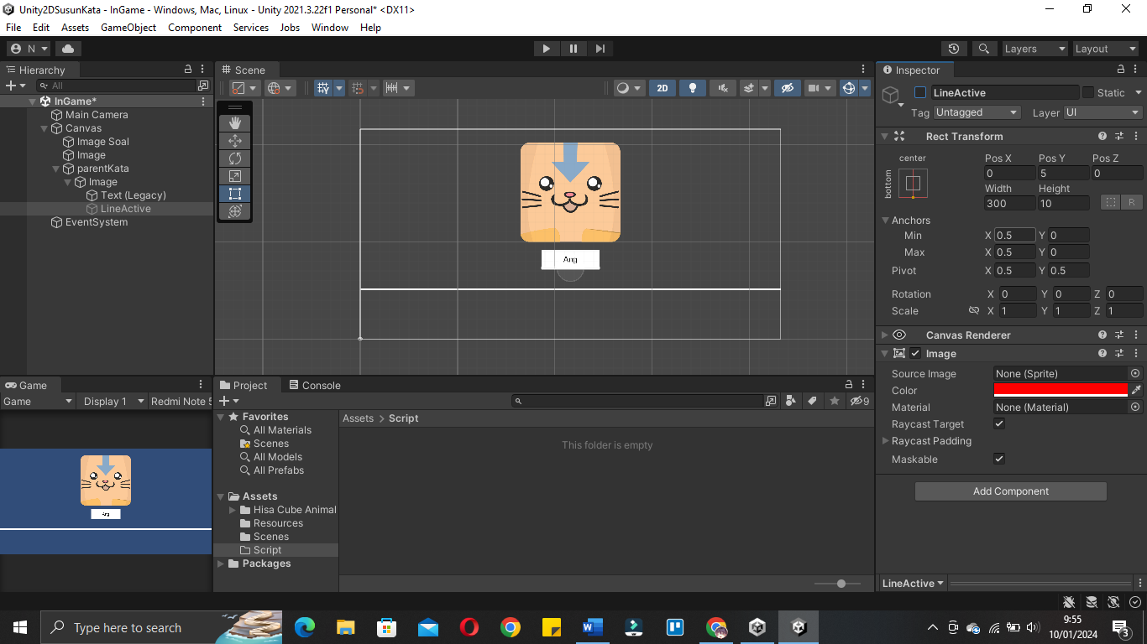

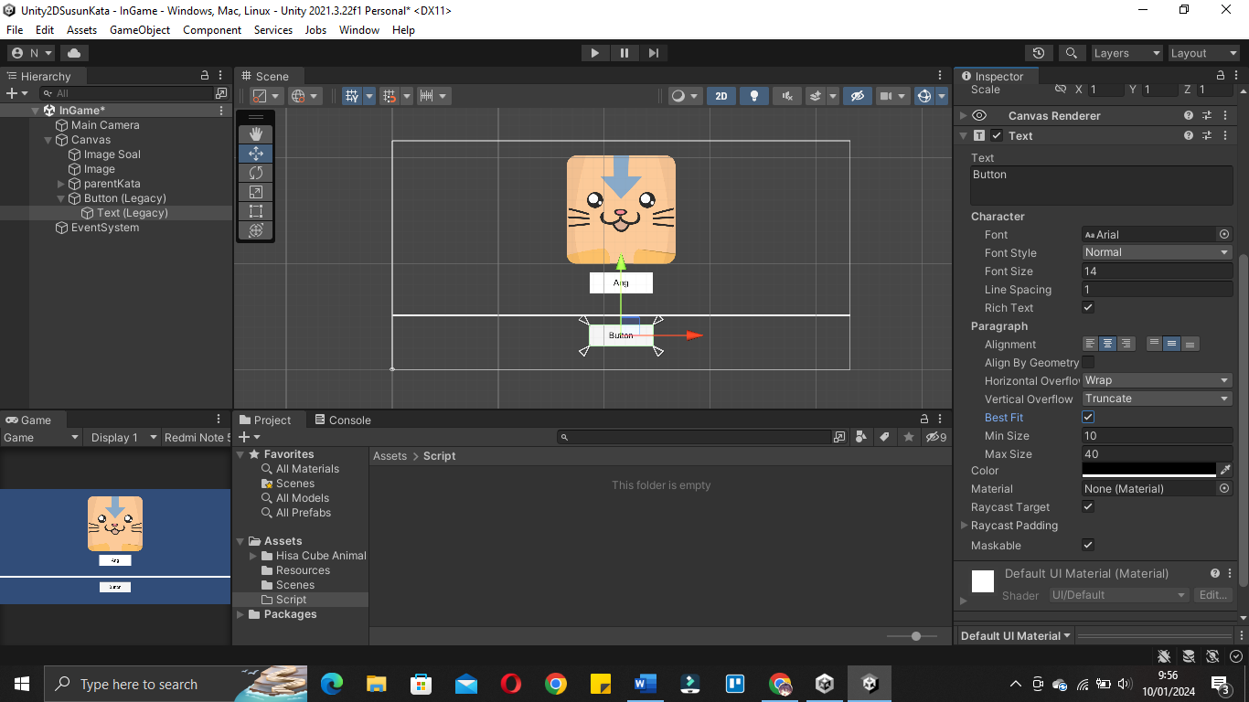

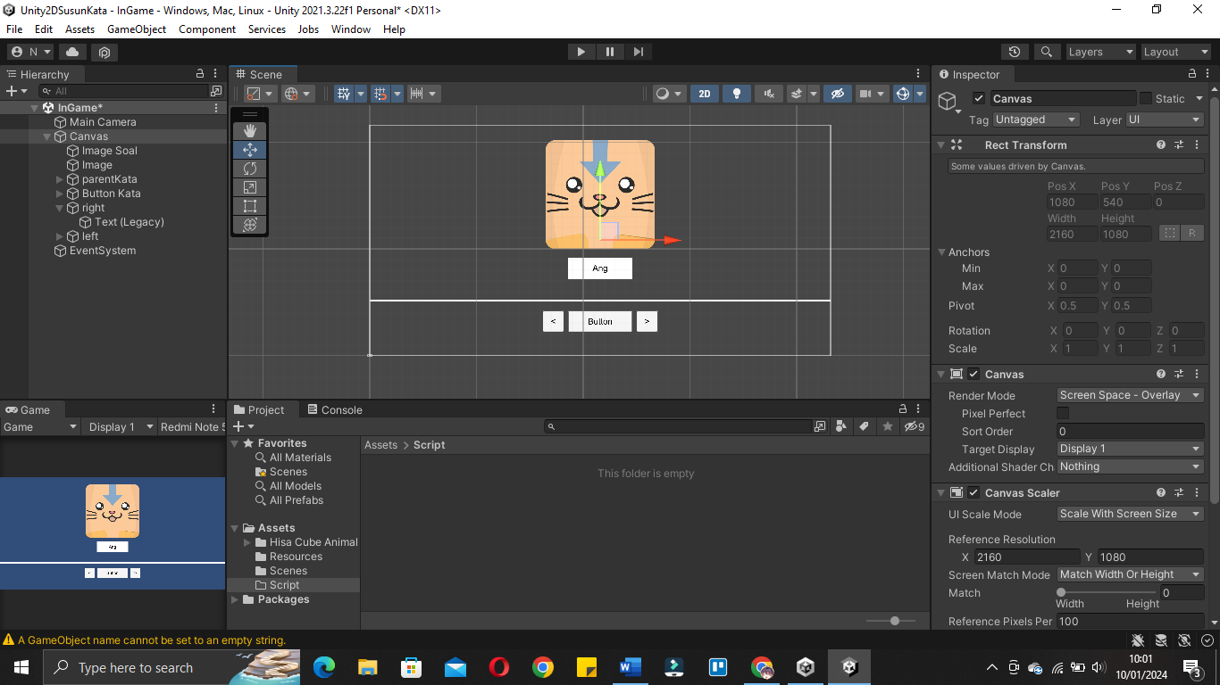

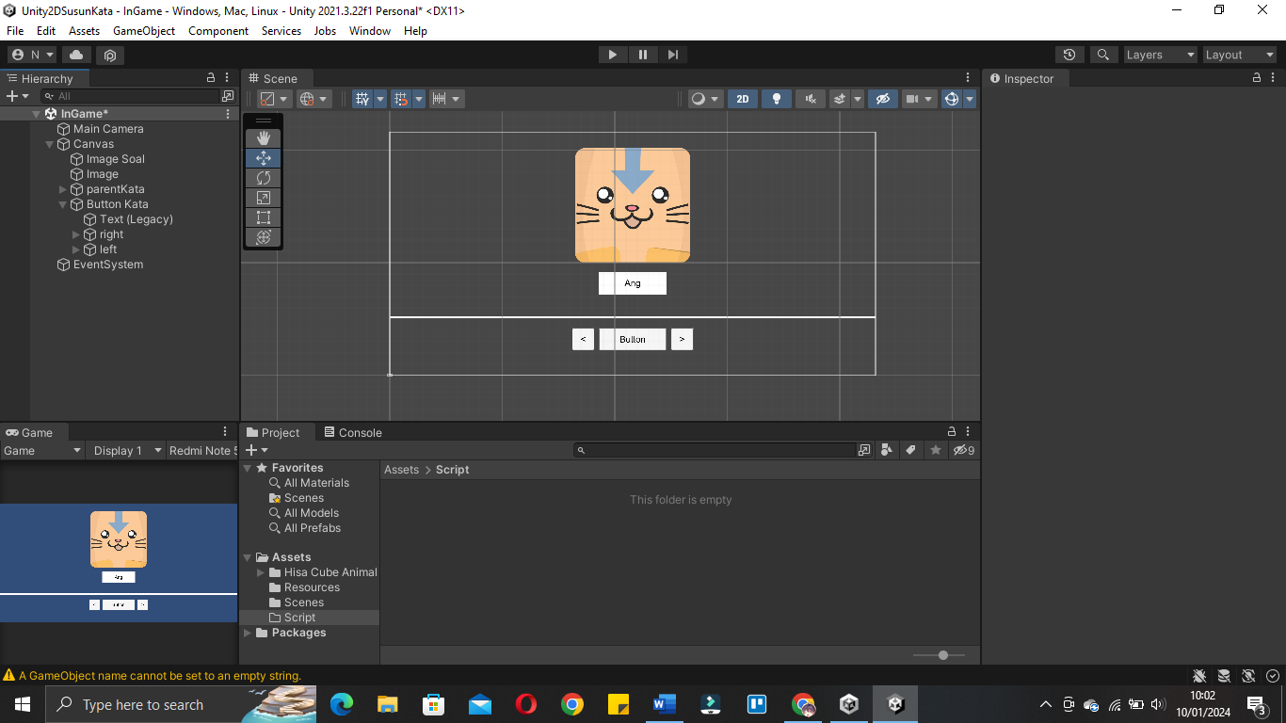

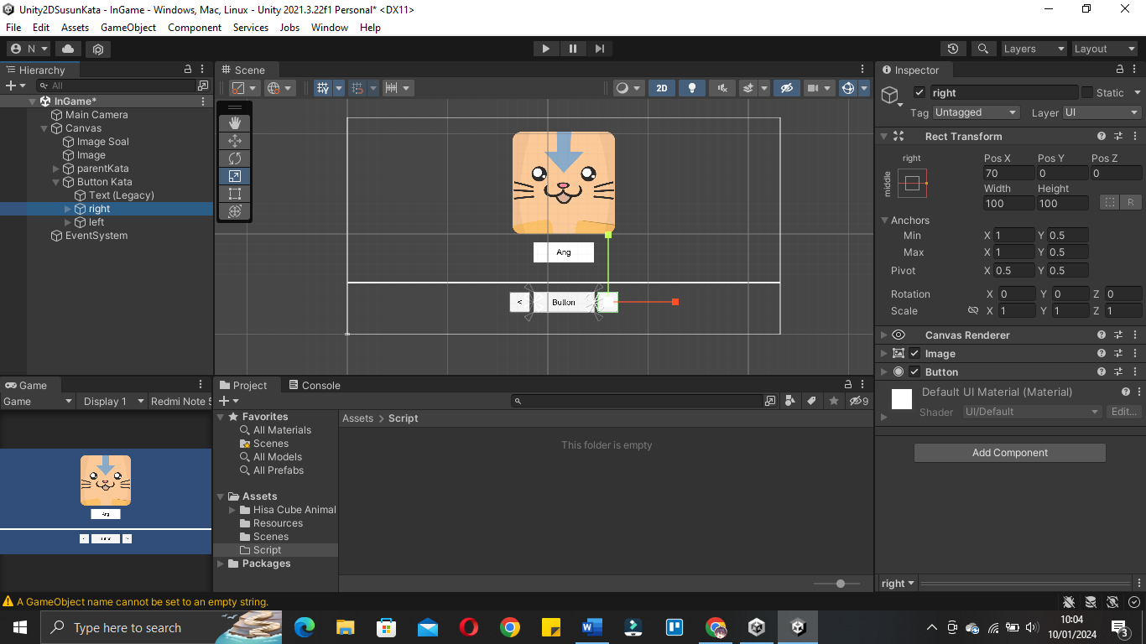

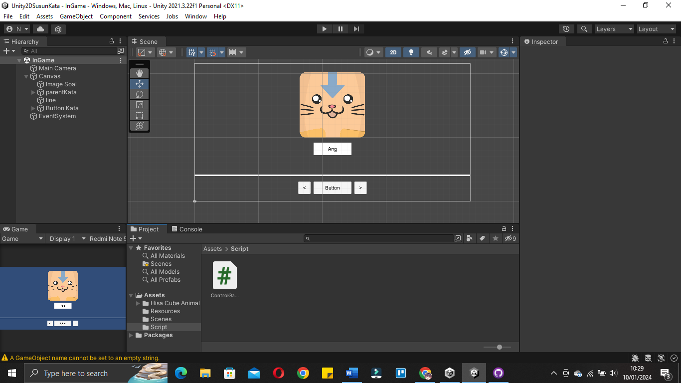

|  |
| --- |
| using System.Collections;  using System.Collections.Generic;  using UnityEngine;  using UnityEngine.UI;  public class ControlGame : MonoBehaviour  {  public int gameRound;  [Header("Image Question")]    public Image ImageSoal;    public Sprite[] spriteSoal;  public int[] indexRandomSprites;  [Tooltip("Jika ingin random tekan ini")]  public bool isRandomSprite;  void Start()//3  {  RandomImageSoal();  }  void RandomImageSoal()//2  {  indexRandomSprites = new int[spriteSoal.Length];//membuat slot secara otomatis sesuai prite yang digunakan  for(int i=0; i<indexRandomSprites.Length; i++)  {  indexRandomSprites[i] = i;//fill element array  }  if(isRandomSprite == true)  {  RandomValue(indexRandomSprites);  }  }  void RandomValue(int[] indexRandoms)//1  {  for(int i=0; i<indexRandoms.Length; i++)  {  int a = indexRandoms[i];  int b = Random.Range(0, indexRandoms.Length);  indexRandoms[i] = indexRandoms[b];  indexRandoms[b] = a;  }  }  } |

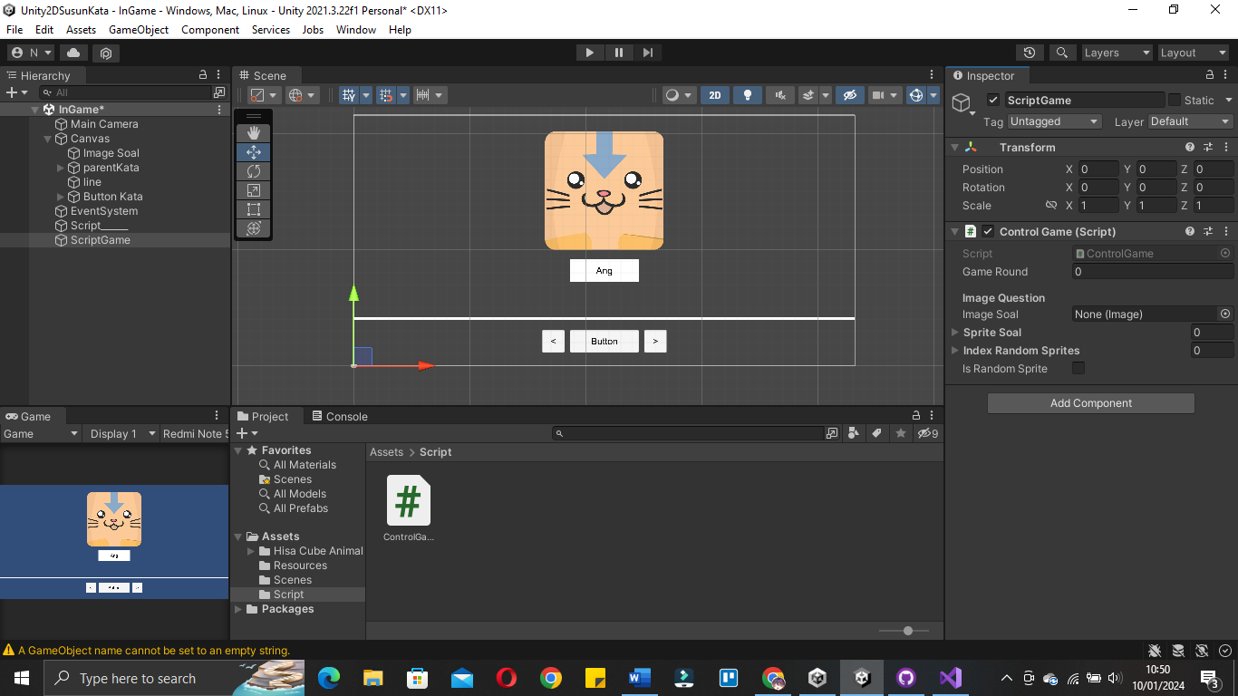

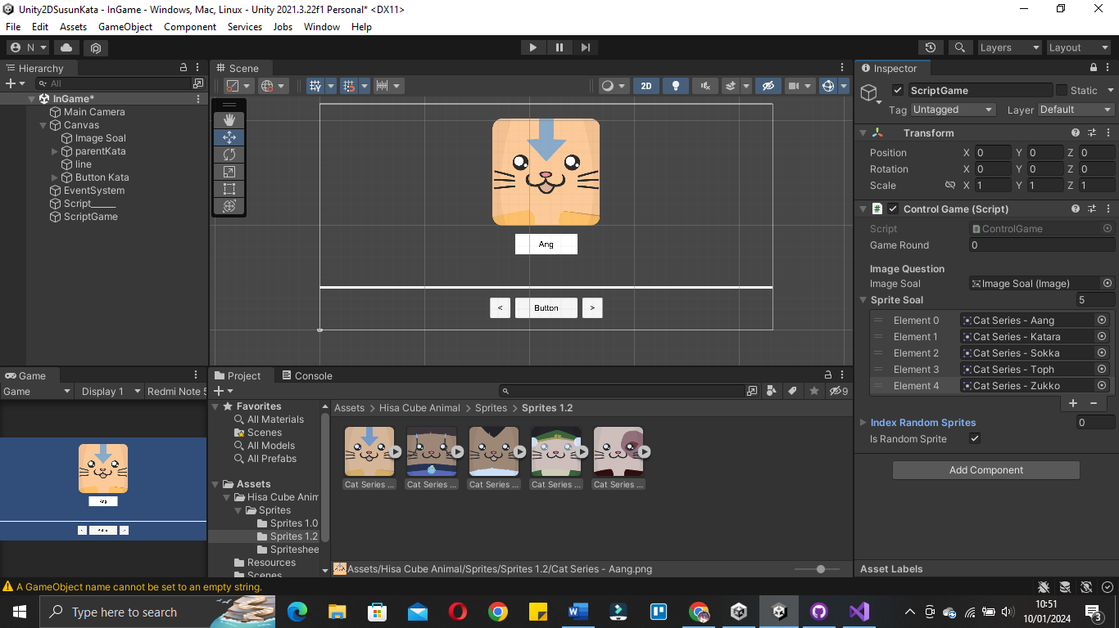

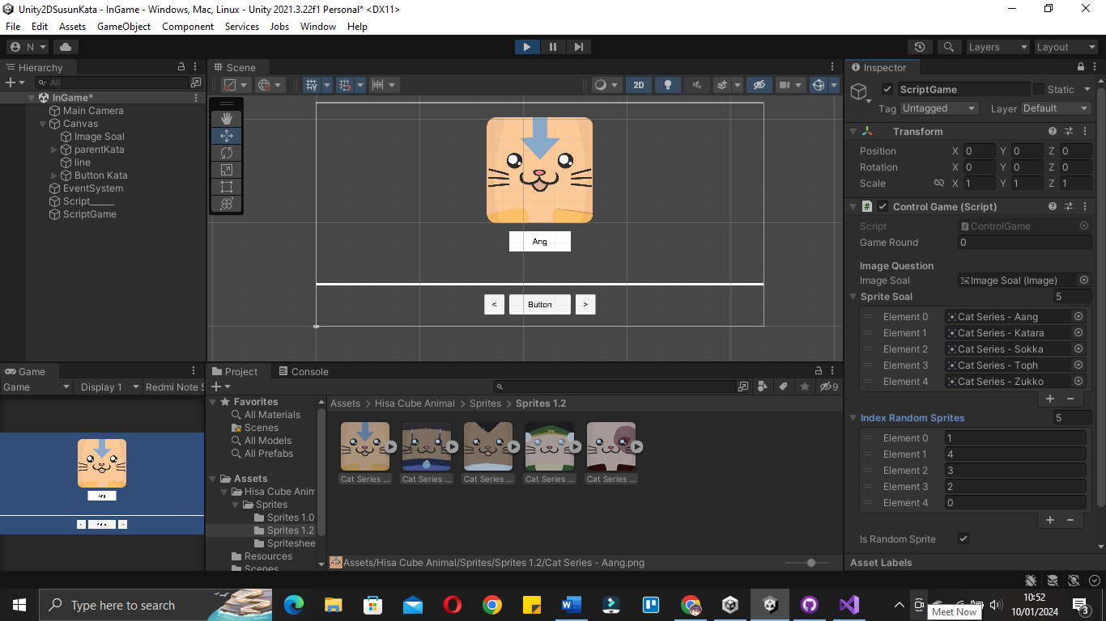

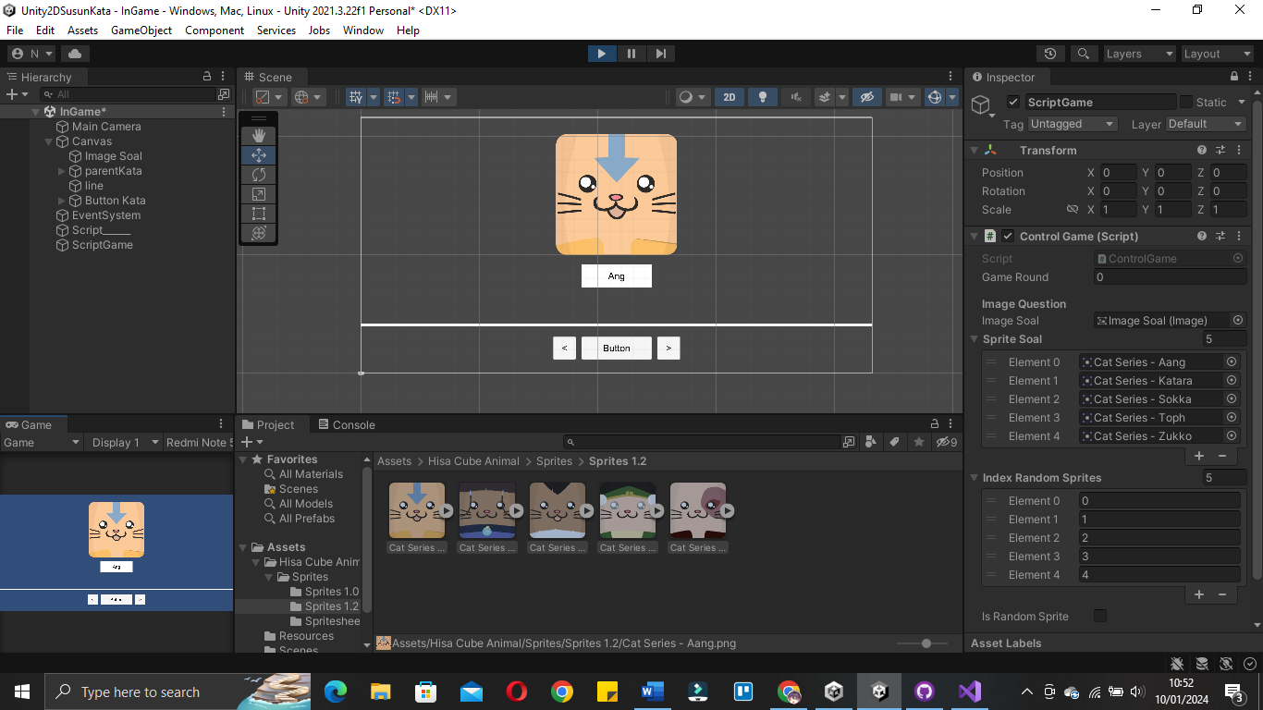

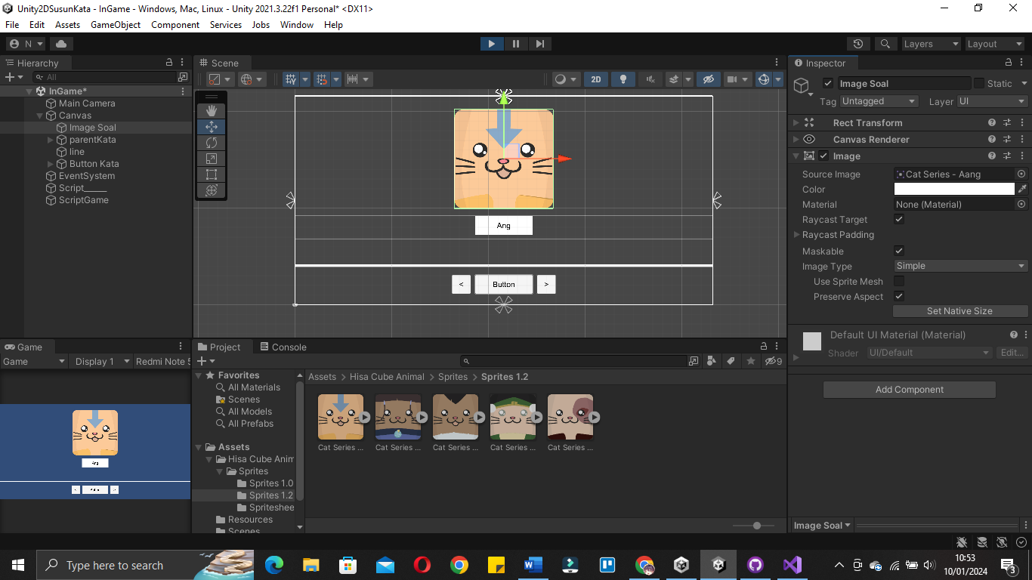

|  |
| --- |
| using System.Collections;  using System.Collections.Generic;  using UnityEngine;  using UnityEngine.UI;  public class ControlGame : MonoBehaviour  {  public int gameRound;  [Header("Image Question")]    public Image ImageSoal;    public Sprite[] spriteSoal;  public int[] indexRandomSprites;  [Tooltip("Jika ingin random tekan ini")]  public bool isRandomSprite;  void Start()//3  {  RandomImageSoal();  }  void RandomImageSoal()//2  {  indexRandomSprites = new int[spriteSoal.Length];//membuat slot secara otomatis sesuai prite yang digunakan  for(int i=0; i<indexRandomSprites.Length; i++)  {  indexRandomSprites[i] = i;//fill element array  }  if(isRandomSprite == true)  {  RandomValue(indexRandomSprites); //acak value  }  ImageSoal.sprite = spriteSoal[indexRandomSprites[gameRound]];//implementasi sprite stelah di acak  }  void RandomValue(int[] indexRandoms)//1  {  for(int i=0; i<indexRandoms.Length; i++)  {  int a = indexRandoms[i];  int b = Random.Range(0, indexRandoms.Length);  indexRandoms[i] = indexRandoms[b];  indexRandoms[b] = a;  }  }  } |

